
My Target:
____ / or _____% Complete on the day of the test.   (Circle when your test is handed back)

Assessment 1 – Introduction to History (Year 7) 2022
In-class Short Answer Response (8%)

____ / 53
Name: __________________________

READING TIME – 5 Minutes WORKING TIME – 50 Minutes

Section 1 – Multiple Choice (10 marks)
*Please circle only ONE answer*

1. How many years is a millennium? (1 mark)

- A period of ten [10] years
- A period of a hundred [100] years
- A period of a thousand [1000] years
- A period of 1,000,000 years

2. A ‘primary source’ is: (1 mark)

- An item from primary school
- Any evidence that was created during the time period of study
- Any evidence that gives us insight in to the time period of study
- The first time you try tomato sauce

3. A ‘secondary source’ is: (1 mark)

- An item from secondary school
- Any evidence that was created during the time period of study
- Any evidence which analyses and interprets primary sources
- Sharing your sauce with a friend

4. A timeline is: (1 mark)
a) Something to do with clocks
b) A list of events in any order
c) A line displaying key events in chronological order
d) A line displaying key events

5. How can historians test the reliability of evidence from sources?
a) Ask a teacher
b) Ask Google
c) Check for bias
d) Compare them with other sources that are available

6. The concept of Significance would best be described as? (1 mark)

- The point of view of the author
- The reason why events occurred
- The importance that is assigned to particular aspects of the past
- That over time, some things change and some things remain the same

7. What best describes an artefact? (1 mark)

- items that have been made or changed by people
- natural items from the past
- animal remains
- myths and legends from the past

8. What do the sources we have for ancient Australia include? (1 mark)

- Papyrus, rock art and pottery
- Rock art and ruins of cities
- Statues and other rock art
- Oral history (stories) and archaeology (such as rock art and tools)

9. BC is also the same as: (1 mark)
- AC
- CE
- BCE
- AD

10. What are the missing words in the following sentence? (1 mark)

___________ is the situation when particular interpretations of the past are open to ________.

- Significance, interpretation
- Contestability, debate
- Contestability, decision
- Perspective, interpretation

Section 2 – Short Responses (43 marks)

- Define the historical concept of perspectives and provide an example. (3 marks)

2 marks for definition (a point of view, the position from which people see and understand events in the world around them)
1 mark for example

- Define the historical concept of evidence and provide an example. (3 marks)

2 marks for definition (the information gathered from historical sources, which can be either primary or secondary, used to help us understand what happened in the past or prove a hypothesis)
1 mark for example

- Place the following dates in chronological order onto the timeline below: (4 marks)

356 BC 1989 CE 776 BCE 1AD 2250 BCE 1BC 2022 AD 1678 CE

2250BCE 776BCE 356BC 1BC 1 AD 1678CE 1989 CE 2022AD

(1/2 mark per correct)

- Categorise the following sources as either primary or secondary. State the word primary or secondary next to each type of source. Watch your spelling! (6 marks)

NAME OF SOURCE | PRIMARY OR SECONDARY SOURCE
A documentary on Otzi the Iceman which shows a re-enactment of how he died | Secondary
The original diary of Anne Frank who experienced the holocaust in World War II | Primary
“Unlocking the Past”, a history textbook written in 2008 | Secondary
A letter from a World War I soldier sent to his family during the Gallipoli campaign. | Primary
The written biography on Cleopatra, published in 1978. | Secondary
Inscriptions on the tomb of Ancient Egyptian Pharoah, Tutankhamun | Primary

- Outline the difference between primary and secondary sources, using examples. (6 marks)

2 marks for outlining what a primary source is
1 mark for multiple examples (1/2 mark if only one provided)

2 marks for outlining what a secondary source is
1 mark for multiple examples (1/2 mark if only one provided)

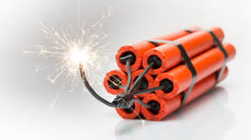
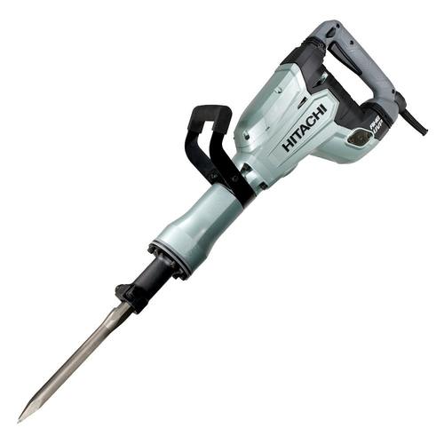
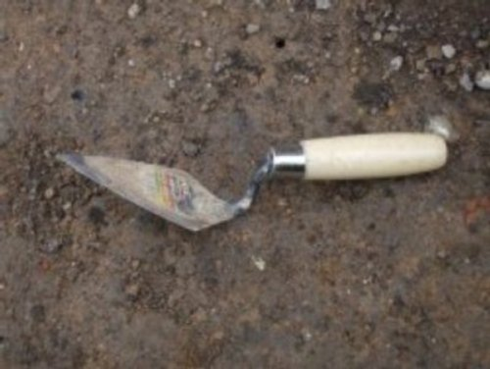

- Select two tools an archaeologist would most likely use to excavate an artefact from below. Outline why they would use this tool. (4 marks)

Dynamite
Jackhammer
Brush
Trowel
Tool 1:
-1 mark for selecting an appropriate tool (trowel or brush)
-1 mark for outlining why this would be used e.g. relates to dig, preservation or artefact

Tool 2:
-1 mark for selecting an appropriate tool (trowel or brush)
-1 mark for outlining why this would be used e.g. relates to dig, preservation or artefact

- Define relative dating with the use of an example. (3 marks)
- 2 marks for correct definition i.e. provides the order of events in the past but does not give a precise year, relies on the experience of the archaeologist
- 1 mark for providing an example e.g. stratigraphy or fluorine dating

- Define absolute dating with the use of an example. (3 marks)

- 2 marks for correct definition i.e. methods used to assess the age of something, is more accurate/modern/scientific.
- 1 mark for providing an example e.g. dendrochronology or radiocarbon dating

- descriptions relating to dating objects. (6 marks)

Stratigraphy Radiocarbon dating Fluorine dating
Relative dating Absolute dating Dendrochronology

- Stratigraphy: when an artefact is given a date because it is found in the same layer of earth(stratum) as another object that can be dated.

- Radiocarbon dating: used for any item that was once alive by measuring the level of carbon – 14 to date the age as carbon decreases at a fixed rate.

- Dendrochronology: a method that dates trees and wooden objects by counting growth rings. This can give information on past climate and to give a year when the tree was cut down and used to make the artefact.

- Relative dating: this form of dating gives an order of events in the past but does not give a precise year. It relies on the experience of the archaeologist and relative findings.

- Fluorine dating: this form of dating is used to date bones by measuring the amount of fluorine that the bone has absorbed from the soil.

- Absolute dating: this form of dating is a more scientific and modern method using a wide range of ways to determine a more exact age.

10. Explain why the jobs of both a historian and an archaeologist are so important. *Extra writing space is provided on the next page if needed* (5 marks)

- 2 marks for detailed explanation of the role of a historian and its importance (1 mark if briefly mentions)
- 2 marks for detailed explanation of the role of an archaeologist and its importance (1 mark if briefly mentions)
- 1 mark for showing relationship between the two jobs

Possible answers could include:
- Historians interpret historical sources and help us to understand what happened in the past.
- Historians preserve and record information and make it accessible to the greater population.
- The work of historians is important because it helps us to learn about the past which can help us to learn from mistakes etc.
- Archaeologists help us to uncover the past and learn about past cultures through studying artefacts and human remains
- Archaeologists assists historians in understanding the past, especially when there are no written records present

End of Assessment

